THE LAB TASK OPERATING SYSTYEM

  - M.Taha F2024332023

Add user
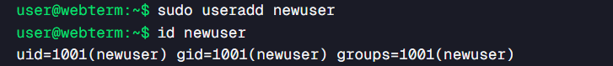

Update user
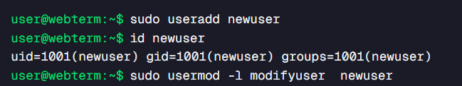

Task manager
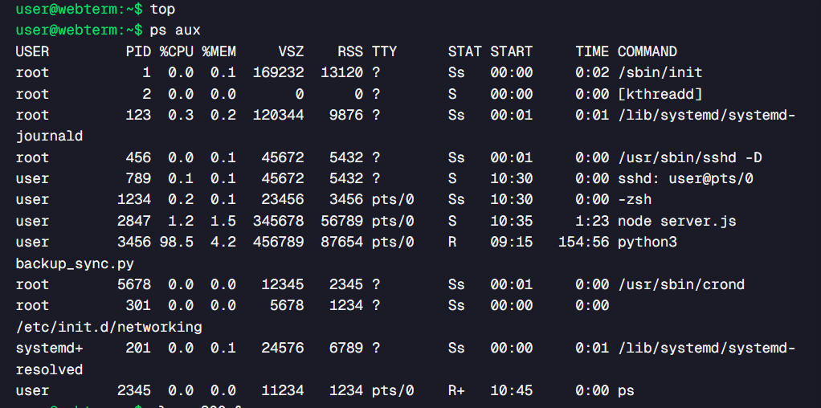

Kill process

